1ST HEALTHCARE

OUT OF HOURS POLICY

STATEMENT OF POLICY
Out of hours on call service provides support and advice to service users and support teams within 1st Healthcare within the Borough and the surrounding Boroughs.

INTRODUCTION
Our on call system is in operation to provide support and advice to staff, and their roles and responsibilities of the Duty Managers are clearly defined within this procedure.
- Tier One Is provided by our Operation Manager and their hours of duty are 8am – 8pm.
- Tier Two Is provided by a Social Worker designated as our Out of Hours from 5pm until 9 am.
Out of hours means between the hours of 17.00pm hours – 09.00am hours (weekdays) & Weekends and Bank Holidays (24 hours).
Line management is referred to within this procedure and means Operations Manager , Business Manager and Director.

CRITERIA
Before the on-call system is used staff must attempt to contact their Line Manager (during working hours). This is with the exception of reporting sickness/absence, which must be reported through the on call system. Managers are normally available Monday-Friday 9.00 Hours –17.00 Hours
Outside these hours (weekdays 09.00-17.00 hours) or in the absence of a response from a Line Manager staff must use the on-call system where they need advice, support or to pass on vital information, e.g.
- Major incidents, especially those involving or requiring the involvement of the Police.
- Service users taken ill or in need of medical services.
- Service users presenting behaviours of concern.
- Service users who are ‘at risk’ and go missing from the premises or following advice of local individual service user guidelines.
- Staff reporting all forms of absence/returning to duty.
- Failure of essential supplies, i.e. gas, electricity, water.
- Irregularities regarding finance or medication.
- Formal complaints.
- Staff incidents/accidents.
- In line with the Missing Persons Procedure any urgent out of hours media enquiries should be referred to the Duty Manager. All other non-urgent media enquiries received out of hours should be referred to the Operations Manager at the start of the next working day.
- Staff reporting all safeguarding issues and concerns of abuse.
The above list is not exclusive, and it is acknowledged that particular circumstances outside of this list may need elevating to the Duty Manager level.

NHS DIRECT
Where a service user is feeling unwell and only when the On-Call Procedure is being initiated may staff contact NHS Direct for further advice (Telephone 111).
Other procedures to reference in relation to the above are:
- Medical Emergencies.
- Incident/Accident Reporting.
- Death of a Service User.
- Concerns at Work – Whistleblowing.

OPERATIONS

NB: The out of hours Duty Manager are not office based. If they are not at work, they will be dealing with issues from their own base. Therefore, when making a telephone call please be sensitive to this fact and ask yourself the question, can the call wait until the morning. Especially if it is between the hours of 23.00 hours and 07.00 hours.

Duty Hours

On Call begins at 5 pm until 9 am the next morning.
At 1st Healthcare, we have a designated Social Worker staff member who undertakes Out of Hours from 5 pm until 9 am the following day.
In their absence, the Out of Hours, will be undertaken by the Operations Manager.

Handover
The Out of Hours staff member will communicate to staff on shift the following morning to the next staff member, ensuring that they are aware of any previous incidents, concerns or health issues.

Policies and procedures
All On-Call Managers can find appropriate policies and procedures on the intranet when dealing with any concerns or incidents.
Phone number to contact is

ON CALL SYSTEM (see flowchart)
When a member of support staff requires the l On Call Manager they must telephone the appropriate phone number …………..
On call Managers must document the following information:
- Time and date of the call
- Name of the caller
- Location of the caller
- Telephone number they can be contacted on
- Reason for the call
- Action/response
23.00 Hours to 07.00 Hours
Calls relating to the following can wait until after 7.00am
- Reporting or returning from sickness absence leave or other absence.
- Irregularities related to financial matters.
In certain instances, it may be necessary for the Duty Manager to attend an incident, these include
- Category A and B incidents,
- Death of a Service User
- Serious Fire Incidents etc.
You MUST contact the Duty Manager and follow the Lone Working protocol.
The Duty Manager will in all cases regardless of time of day/night notify the Directors of the following:
- Admission of service users to Hospital (if health has severely deteriorated).
- Attendance of service users or staff (if on duty) at an Accident and Emergency Department (if Category A or B incident).
- Death
- Car accidents where the intervention of the Police has been necessary.
- Incidents of aggression, which fall into the Categories A, B.
- Missing persons.
- Security incidents and vandalism where the intervention of the Police has been necessary.
- Failure of essential supplies (Gas, Electricity and Water) if service user health or safety is compromised.
- Fire incidents.
- Floods
- Staff on duty who are under the influence of drink, drugs, etc.
- Authority for overtime and use of Agency Staff related to points listed above.
- Concerns for service user’s safety and issues of concern.
The Duty Manager will in all cases notify the Director between the hours of 7.00 – 23.00 hours of the following:
- Admission of service user to Hospital.
- Attendance of service users or staff (if on duty) at an Accident and Emergency Department.
- Errors in service user taking their medication incorrectly.
- Complaints and/or allegations.
- Failure of essential supplies (Gas, Electric and Water).
- Concerns for service user’s safety and issues of concern.
If in doubt contact the Senior Manager.
The person requesting the Duty Manager must make a written entry in the 24 Hour Report Book of:
- The time the Duty Manager was requested.
- On call response time.
- Advice given by the Duty Manager.
- If the Duty Manager visited.
Where a Duty Manager fails to respond to a call after two attempts, the Director will be contacted for support.

Responsibilities of Duty Managers
(Driving and Use of Mobile Phones)
On call staff must also refer to the Telephones Procedure.
Due to the introduction of new laws and the use of mobile phones staff who are on call are not permitted to respond to mobile phones whilst driving, which may affect the 5-minute response time allowed following a call.

APPENDIX A - MEDICINE PROCEDURE - AS REQUIRED MEDICATION
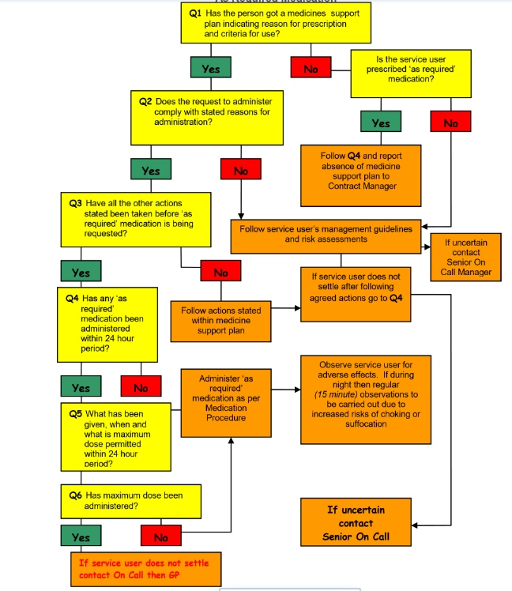

APPENDIX B - MEDICAL EMERGENCY
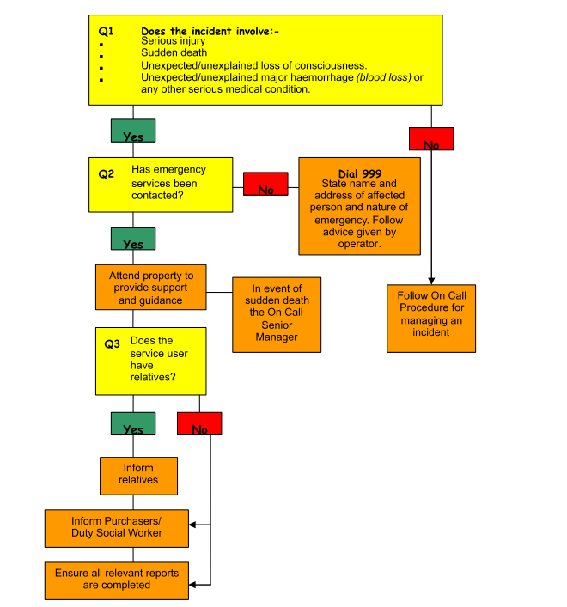

APPENDIX C - SERIOUS / UNTOWARD INCIDENTS
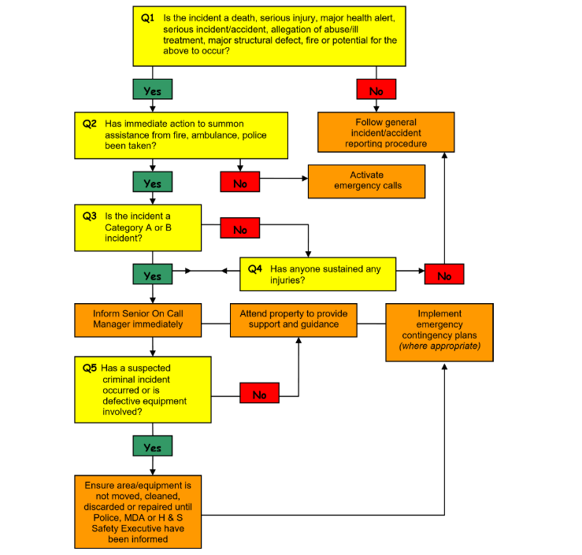

APPENDIX D - CONCERNS AT WORK
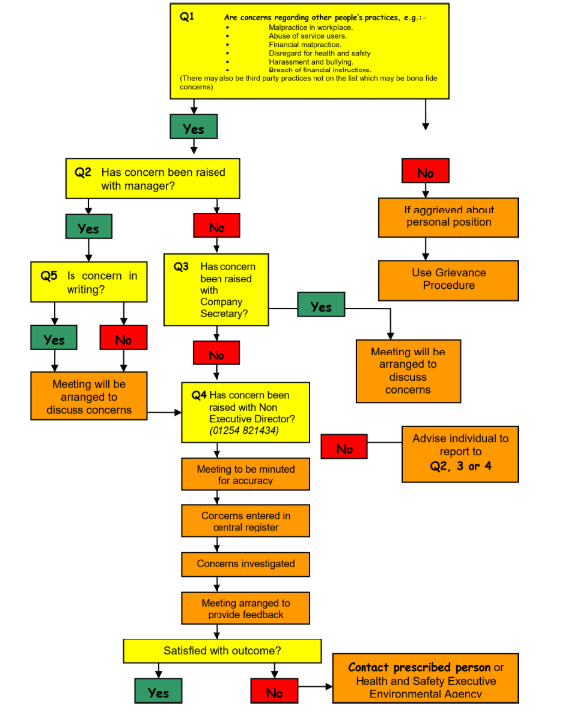

APPENDIX E - SERVICE USER MISSING / AT RISK
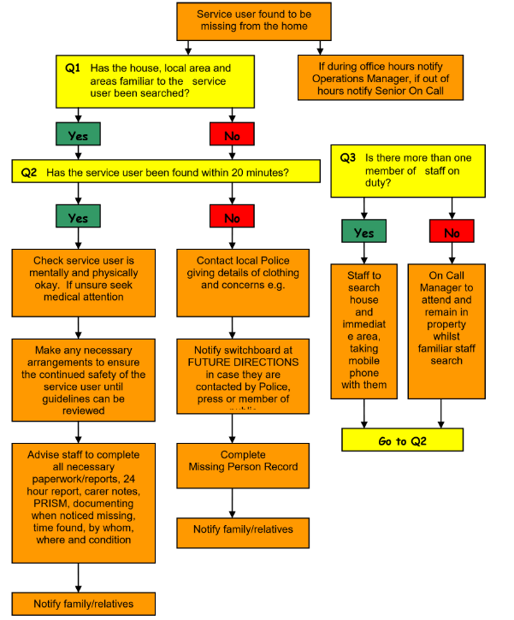

APPENDIX F - DEATH OF A SERVICE USER
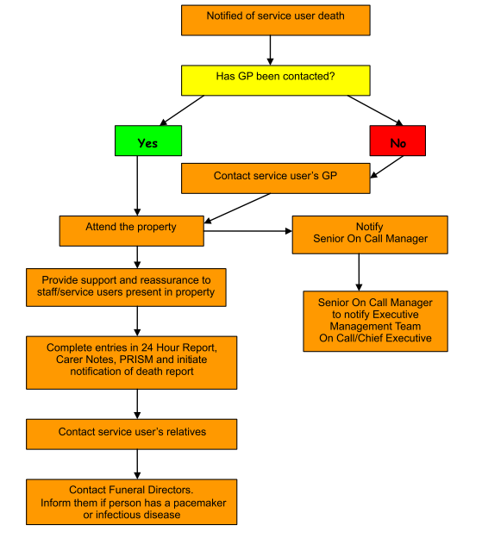

APPENDIX G - SICKNESS PROTOCOL
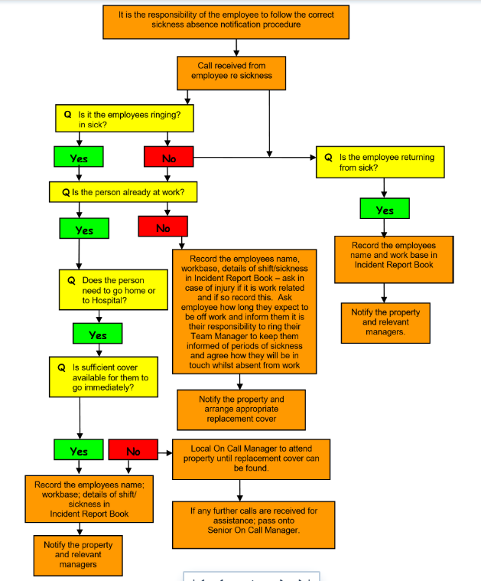

APPENDIX H - INCIDENT / ACCIDENT REPORTING
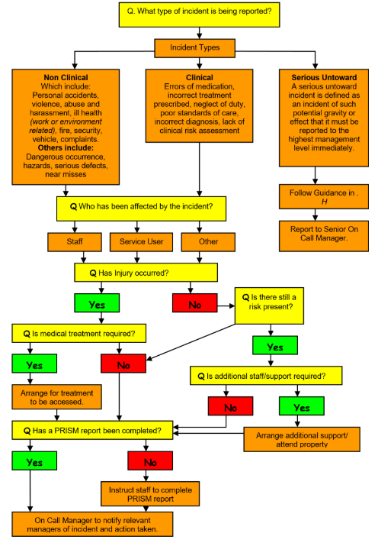

APPENDIX I - FORMAL COMPLAINTS
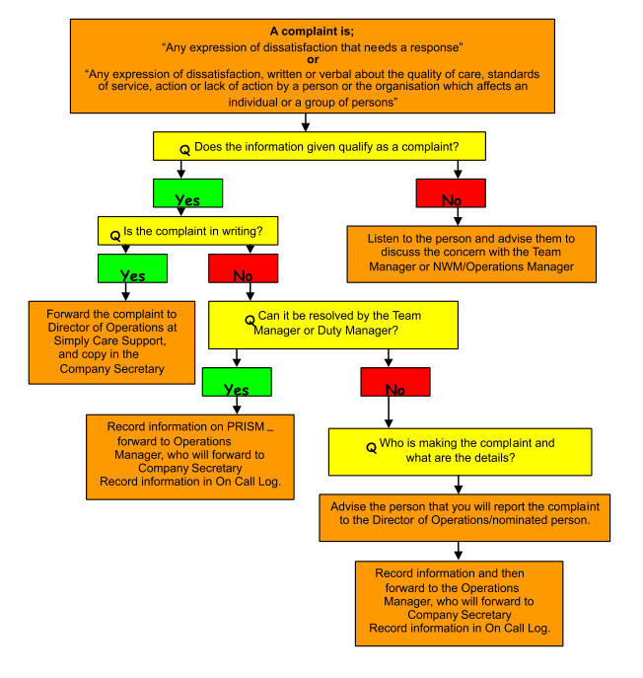

APPENDIX J - ON CALL SYSTEM

